SKINTELLECT: AI + IOT BASED SKIN ANALYSIS & RECOMMENDATIONS SYSTEM

STORY

In the past, obtaining a comprehensive skin analysis was a cumbersome and time-consuming process, impacting people's daily lives in various ways. The journey often began with individuals recognizing the need to assess their skin health due to concerns or changing skin conditions. To get their skin analysed, individuals had to schedule appointments with dermatologists or specialized skin clinics, juggling busy work schedules and personal commitments to make time for these visits. The first obstacle was navigating through traffic and commuting to the clinics, which consumed valuable time and added stress to an already hectic lifestyle. Once at the clinic, patients often faced long wait times before meeting the dermatologist.

During the initial consultation, the dermatologist conducted a basic examination of the skin. However, for a more detailed analysis, additional specialized tests were often recommended, requiring separate appointments and further waiting for test results. The process of visiting the clinic multiple times for different tests meant days and even weeks of waiting for comprehensive results, leading to anxiety and uncertainty, causing further frustration. For individuals with demanding careers and busy personal lives, taking time off for multiple clinic visits was not only inconvenient but also challenging, balancing professional commitments with the pursuit of skin health became a daunting task.

Upon receiving the skin analysis report, patients often found the recommendations to be generic and lacking personalization, realizing that a more tailored approach to skincare was necessary for optimal results. However, this historical narrative underwent a paradigm shift with the advent of modern solutions that revolutionized skincare analysis. The introduction of technology, artificial intelligence, and innovative concepts marked a transformative era in skincare.

The integration of artificial intelligence empowered individuals to take charge of their skin health like never before, providing personalized care that addressed their specific skin conditions. This transformative shift marked a profound change, freeing people from the burden of time-consuming clinic visits and granting them the power to make informed skincare choices on their terms. Modern solutions opened new possibilities, allowing individuals to effortlessly integrate skincare analysis into their busy lives. With personalized benefits, individuals could embark on a journey of skincare with confidence, knowing that optimal results were within reach - all through a simple, efficient, and modern solution.

INTRODUCTION

This innovative project is designed to revolutionize the process of obtaining a comprehensive skin analysis and personalized skincare recommendations. By leveraging advanced technologies such as the W5300-MQTT-CAM and QRCode based system with a small display screen, artificial intelligence, and data-driven analysis, it offers a seamless and user-friendly experience.

Users can approach the booth and view a small display screen that shows a QR code for scanning. The moment a person comes within 1-meter range of the booth, the display screen activates and presents the QR code for scanning. If no one is in the proximity, it displays an inviting message, "Try SKINTELLECT!".

Once the user scans the QR code using their smartphone, the skin analysis process is initiated. They are then prompted to input their email id, phone number, age, and gender, which is collected and stored for further communication.

The W5300-MQTT-CAM module captures the user's picture, and the image is processed in the background using AI algorithms for skin pigmentation, skin tone, wrinkles, and skin contrast analysis.

The AI module generates values for various skin parameters, creating a detailed skin analysis report. This report includes insights into the presence of wrinkles, skin tone, skin texture, and pigmentation, along with personalized recommendations. The results are sent to the user's email id and phone number via email and SMS.

Additionally, this project includes Telegram notifications, where an automated message is sent to the administrator's Telegram account after the report is generated.

Moreover, this project offers personalized product recommendations powered by OpenAI (GPT 3.5), tailored to each individual's specific skin needs and concerns based on their analysis results.

By eliminating the need for multiple visits to dermatologists or clinics and reducing waiting periods for results, this project empowers users to take charge of their skincare journey conveniently and efficiently, making informed decisions for healthier and radiant skin. It also benefits skincare professionals and booths by enhancing customer experiences with detailed skin analysis and tailored product recommendations.

With a user-friendly interface and data-driven approach, this project promises to revolutionize skincare analysis, offering a seamless and personalized skincare experience for all users. It unlocks the true potential of every individual's skin health, making it an indispensable tool in the skincare industry. The future of skincare analysis is brighter than ever with this innovative project, offering a new era of personalized care.
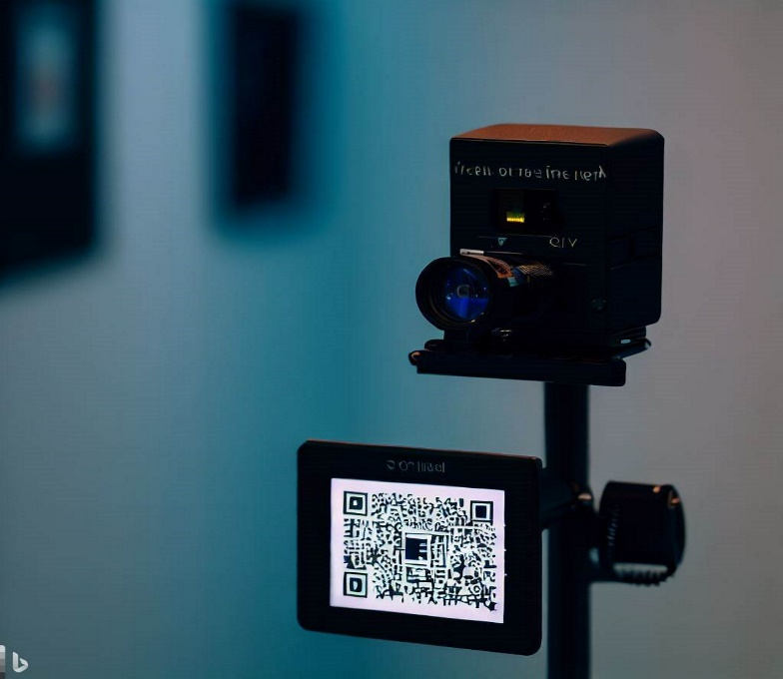

(Reference image)

WHY SKINTELLECT?

- Advanced technology: IoT, AI, and data-driven analysis.
- Personalized skincare recommendations based on individual analysis.
- Convenient and efficient - QR code scanning for analysis.
- Secure data handling for privacy protection.
- Enhanced customer experience with detailed reports.
- Hassle-Free Setup and Usage

LIBRARIES, SOFTWARE COMPONENTS AND ONLINE SERVICES USED
Here's the list of software components used in the project:
1. Flask
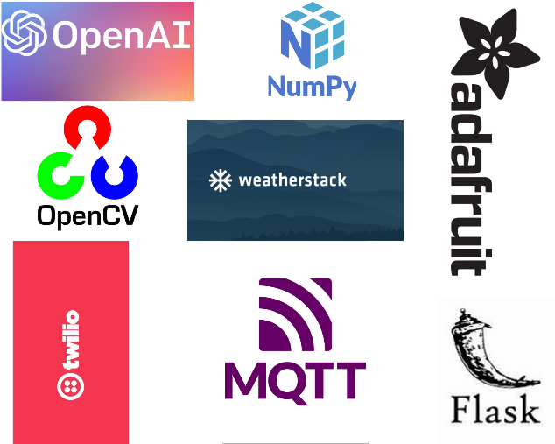
2. MQTT broker
3. mtcnn
4. OpenCV
5. Adafruit SSD130
6. Twilio API
7. smtplib
8. requests
9. jsonify
10. Weatherstack API
11. OpenAI (GPT 3.5)
12. Telegram Bot API

HARDWARE COMPONENTS USED
Here's the list of hardware components used in the project:
- Ultrasonic sensor (HC-SR04)
- OLED display (Adafruit SSD1306)
- WIZnet W5300 TOE Shield Board
- OpenMV H7 camera module
- Jumper wires
- Breadboard

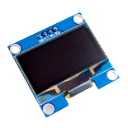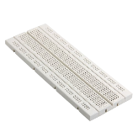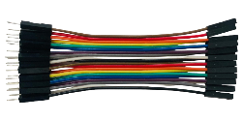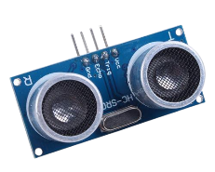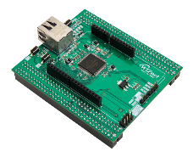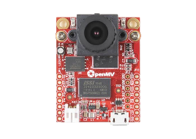

PROGRAMMING LANGUAGES USED
Here's the list of programming languages used in this project:

- Python
- HTML
- CSS
- JAVASCRIPT
- C/C++

WORK FLOW (USER SIDE)

From the user's perspective, the overall working of the SKINTELLECT project can be explained as follows:

1. QR Code Interaction: Users approach the SKINTELLECT booth with an integrated small screen and camera. A QR code is displayed on the screen when a user is within a 1-meter range, encouraging them to scan it using their smartphone's camera.

2. Dynamic User Input: After scanning the QR code, users are prompted to input their email address, phone number (with country code), age, and gender. Valid inputs are required for further analysis.

3. Analysis Initiation: Once the required details are provided, users tap the "Start Analysis" button. This triggers JavaScript to collect and send the data to the server for processing.

4. Backend Processing: Using Flask, the server communicates with MQTT. It sends a command via MQTT to capture the user's facial image through the attached W5300-MQTT-CAM device.

5. Facial Image Capture: The W5300-MQTT-CAM captures the user's facial image, which undergoes computer vision analysis. MTCNN identifies if a face is present.

6. Skin Attribute Assessment: Skin analysis begins if a face is detected:
- Wrinkle Detection: The number of edges on the face indicates wrinkle presence.
- Skin Tone Analysis: LAB colour space assesses skin tone.
- Skin Texture Analysis: GLCM calculates contrast and dissimilarity for texture.
- Pigmentation Analysis: HSV colour space isolates pigmented regions.

7. Comprehensive Analysis: Collected data, analysis results, and user inputs compile into a detailed skin analysis report.

8. AI-Powered Recommendations: The report prompts OpenAI. AI generates personalized skincare suggestions based on analysis results and user data.

9. Instant Recommendations: Users receive skincare recommendations via email and SMS, delivered by Gmail SMTP and Twilio APIs.

10. Administrator Alert: The administrator gets a Telegram notification when a report is generated. This can aid further product analysis.

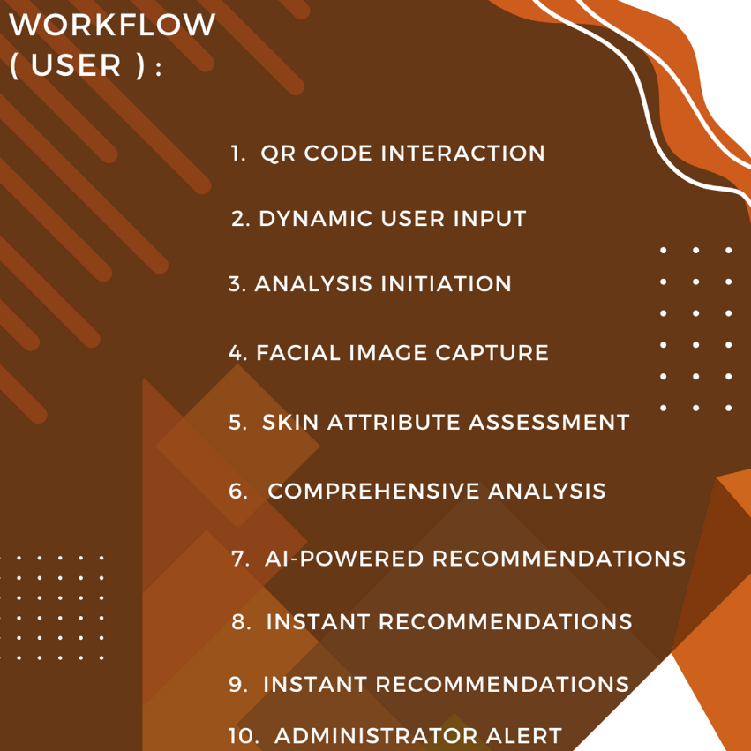
This innovative update enhances user engagement by displaying a QR code on a screen for proximity-based interaction, streamlining the process and making personalized skincare accessible in a touchless manner.

MODULES
Here's a detailed explanation of each module in a step-by-step manner:

1. Web Frontend Module:
- This module creates the user interface for the SKINTELLECT web application.
- It displays a header with the title "SKINTELLECT" and a subheading "Intelligent Skin Analysis."
- It includes input fields for the user to enter their email address, phone number, gender, and age.
- The user clicks the "Start Analysis" button to initiate the skin analysis process.

2. Flask App Module:
- The Flask app module handles incoming requests from the web frontend.
- When the user clicks the "Start Analysis" button, the app collects the entered data, including email, phone number, gender, and age.
- It then sends a request to the MQTT Module to trigger image capture by the W5300-MQTT-CAM device.
- Once the image is uploaded, it is stored and an HTTP URL is generated.
- This URL offers a direct path for any internet-connected device to access the image.

3. W5300-MQTT-CAM Interface Module:
- WIZnet W5300-TOE-Shield: This module is intricately connected to the STM32 Nucleo-144 (F429ZI) boards, acting as the linchpin for internet connectivity. With its high-speed data transmission capability, the shield ensures real-time or near-real-time transmission of images, depending on the chosen resolution.
- Upon receiving the request from the Flask app, it sends a command to the W5300-MQTT-CAM to capture the user's facial image.
- The OpenMV camera module captures high-quality images on command
- The captured image is then saved for further processing.

4. Image Processing Module:
- The Image Processing module processes the captured facial image to analyse skin attributes.
- It uses the MTCNN algorithm for face detection to locate the user's face in the image.
- After detecting the face region, it calculates the number of wrinkles based on the edges in the face region.
- It analyses the colour and texture of the skin to determine skin tone and skin contrast.
- Additionally, it identifies skin pigmentation by isolating pigmented regions in the image.

5. Recommendation Module:
- The Recommendation module generates personalized skincare recommendations based on the user's skin analysis results and other input data.
- It sends the skin analysis results to the OpenAI API to request detailed skincare suggestions.
- The OpenAI model processes the input and generates personalized recommendations.
- The generated recommendations are received and extracted from the OpenAI API response.

6. Email Module:
- This module sends the personalized skincare recommendations to the user's email address.
- It uses the Gmail SMTP server for sending the email.
- The email includes the skin analysis results, along with the generated skincare suggestions.

7. SMS Module:
- The SMS Module sends personalized skincare recommendations to the user's phone number via SMS.
- It integrates with the Twilio API for sending SMS messages.
- The SMS includes the skin analysis results and the skincare suggestions.

8. Telegram Notification Module:
- This module sends a notification to the user's Telegram app to inform them that the SKINTELLECT report has been generated.
- It utilizes the Telegram bot API for sending the notification.
- The notification message includes a prompt for the administrator that a report has been generated for someone (providing no other information, for privacy).
- This is mainly for administrative purpose for better analysis of how product is being used etc…

9. Data Handling Module:
- The Data Handling module is responsible for securely storing and retrieving user data, including email addresses, phone numbers, and skin analysis results.
- It ensures that user data is properly handled and protected.

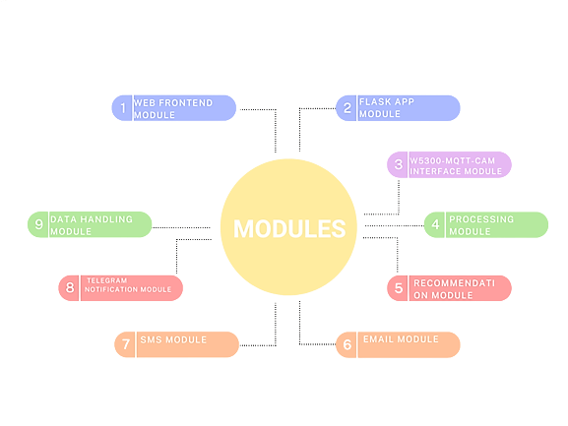

BACKEND PROCESS (DEVELOPER SIDE)

Backend Process of SKINTELLECT:

1. Web Frontend Interaction and Proximity Detection:
- When a user is within a 1-meter range of the SKINTELLECT device, they can access the SKINTELLECT web application by scanning a QR code (that gets displayed on oled screen attached only when user is in 1 meter range: ultrasonic sensor otherwise shows “Try Skintellect!!” message) and opening a web browser on their device.
- They are greeted with a header displaying the title "SKINTELLECT" and a subheading "Intelligent Skin Analysis."
- Input fields are provided for the user to enter their email address, phone number (including the country code), gender, and age.
- To initiate the skin analysis process, the user clicks the "Start Analysis" button.

2. Flask App Communication:
- The Flask app module is activated when the user clicks the "Start Analysis" button after filling in their details.
- The Flask app collects the entered data, including the user's email address, phone number, gender, and age.
- This data is then packaged into a request to be sent to the MQTT module.

3. W5300-MQTT-CAM Image Capture:
- The request from the Flask app module reaches the W5300-MQTT-CAM interface module.
- Upon receiving the request, this module communicates with the W5300-MQTT-CAM device.
- A command is sent to the W5300-MQTT-CAM device to capture the user's facial image.
- The captured image is then stored for further processing.

4. Image Processing and Analysis:
- The captured facial image undergoes analysis in the Image Processing module.
- The MTCNN algorithm is used for face detection, accurately locating the user's face within the image.
- The module calculates the number of wrinkles by analysing the edges in the facial region.
- Skin tone and skin contrast are determined by analysing the colour and texture of the skin.
- Pigmentation regions are identified by isolating specific colours in the image using the HSV colour space.

5. Data Integration with OpenAI:
- After skin attributes are analysed, the Recommendation module comes into action.
- The skin analysis results, along with other input data, are sent to the OpenAI API.
- The OpenAI model processes this input and generates personalized skincare recommendations tailored to the user's skin analysis and other factors.

6. Sending Recommendations via Email and SMS:
- The personalized skincare recommendations are sent to the user via both email and SMS.
- The Email module uses the Gmail SMTP server to send an email containing the skin analysis results and skincare suggestions.
- The SMS module integrates with the Twilio API to send an SMS message to the user's phone number, including the same information.

7. Telegram Notification for Admin:
- Additionally, the Telegram Notification module provides administrative oversight.
- A notification is sent to the administrator's Telegram app, indicating that a report has been generated.
- This notification helps administrators keep track of the reports generated and usage trends without compromising user privacy.

8. Secure Data Handling:
- Throughout this process, the Data Handling module ensures the proper handling and protection of user data.
- User information, such as email addresses, phone numbers, and skin analysis results, are securely stored and retrieved as needed.

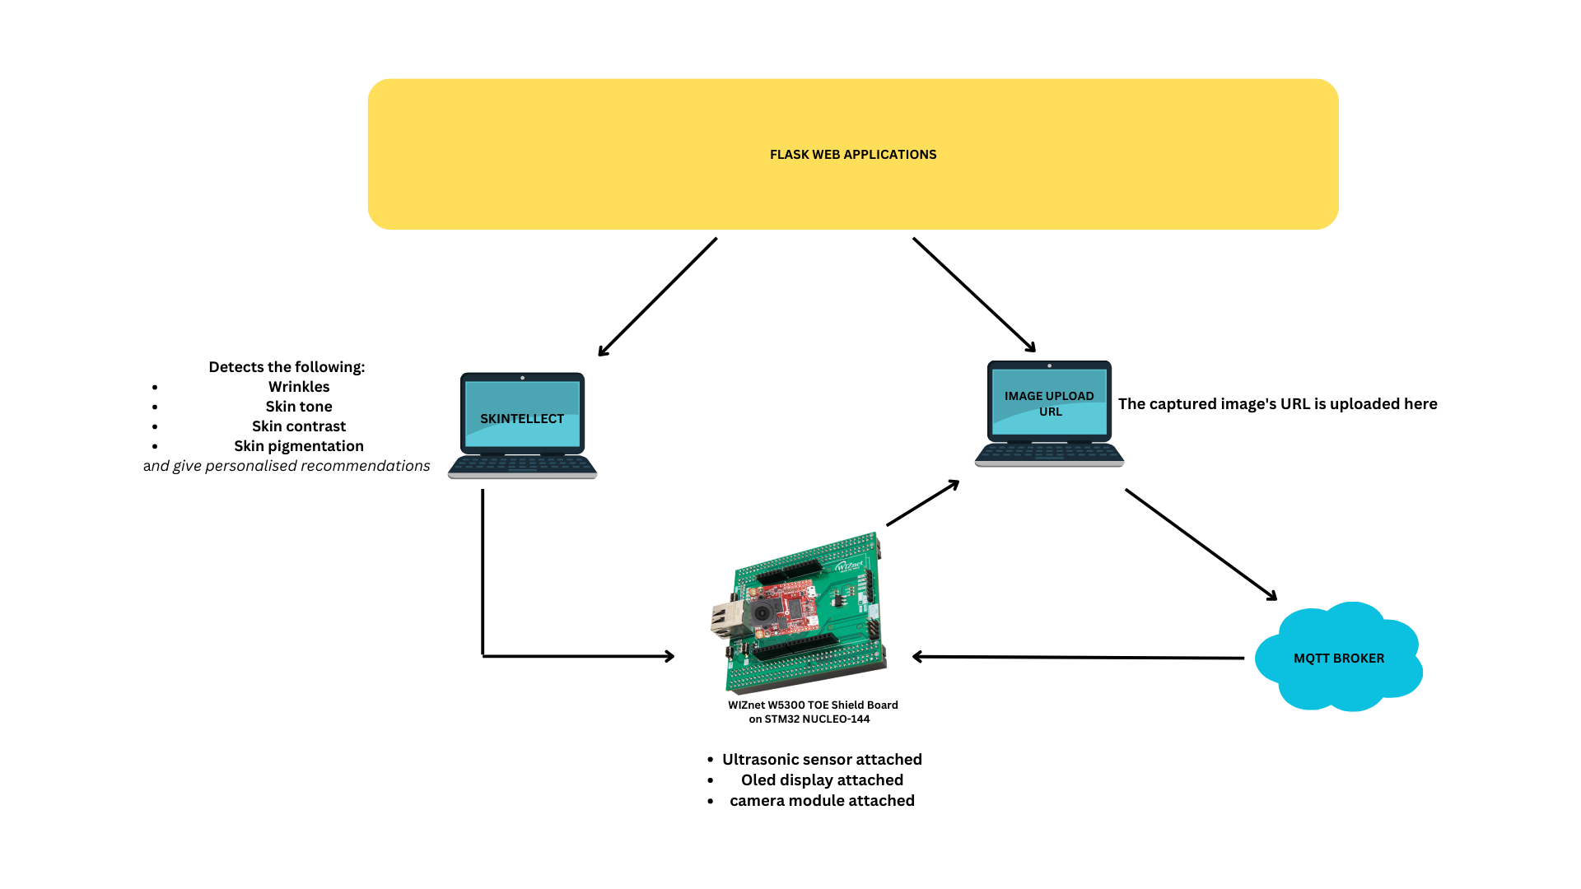

GET STARTED

Let's walk through the detailed steps to set up and run the SKINTELLECT application on a different machine, incorporating the ultrasonic sensor and Adafruit OLED screen. This comprehensive guide covers hardware setup, software configuration, API integration, and more:

Arduino Environment:
To configure Arduino environment for STM32 Nucleo-144 (F429ZI), you need to follow the instructions of WIZnet official website.
LINK: https://github.com/Innovation4x/W5300-MQTT-CAM#arduino-environment
Hardware Setup:

1. W5300-MQTT-CAM Device Setup:
- Connect the W5300-MQTT-CAM device to the machine using the appropriate interface (e.g., USB).
- Ensure the device is recognized by the operating system. Install any required drivers or libraries
for the W5300-MQTT-CAM to function properly.

2. Ultrasonic Sensor and Adafruit OLED Setup:
- Connect the ultrasonic sensor to the machine's GPIO pins according to its specifications.
- Connect the Adafruit OLED screen to the machine's GPIO pins as well.
- Make sure both the ultrasonic sensor and OLED screen are correctly recognized by the system.

PIN CONFIGURATION:
Pin1 (Vcc) | 3V3
Pin 2 (Ground) | GND
Pin3 (SCL) | GPIO PIN (15)
Pin4 (SDA) | GPIO PIN (14)

BOARD PIN
BOARD PIN
OLED PIN
(Vcc) | 5V (VBUS)
(Trigger) | GPIO PIN (11)
(Echo) | GPIO PIN (12)
(Ground) | GND

ULTRASONIC SESNOR PIN

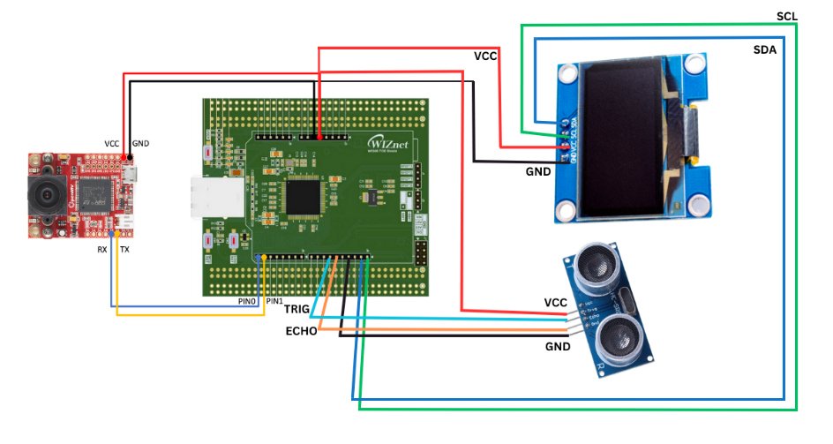
CONNECTION:

HARDWARE CONFIGURATION FOR OPENMV CAMERA MODULE AND STM32 NUCLEO-144 BOARD:

Prepare Both Modules:
- Ensure both the STM32 Nucleo-144 board and the OpenMV camera module are powered off to prevent any accidental shorts or damage.
- Lay out both modules on a non-conductive surface.

Serial Connection:
- Connect the TX pin (pin 1) of the STM32 Nucleo-144 board to the UART3_RX (P5) pin of the OpenMV camera module. This will allow the Nucleo-144 board to transmit data which the OpenMV camera module will receive.
- Connect the RX pin (pin 0) of the STM32 Nucleo-144 board to the UART3_TX (P4) pin of the OpenMV camera module. This setup ensures the Nucleo-144 board can receive data transmitted by the OpenMV camera module.

Power Connection:
- Connect the GND (Ground) pin of the OpenMV camera module to the GND pin of the STM32 Nucleo-144 board. This establishes a common ground between the two devices.
- Connect the VCC pin of the OpenMV camera module to the VCC (or an appropriate power supply pin, depending on the voltage requirements of the OpenMV) pin of the STM32 Nucleo-144 board. This will power the camera module.

Software Setup:
3. Python Installation:
- If Python is not already installed on the machine, download and install the latest version from the official Python website: https://www.python.org/downloads/

4. Environment Setup:
- Open a terminal or command prompt and navigate to the project directory.
- Create a virtual environment (recommended) to isolate project dependencies:
python -m venv skintellect-env

- Activate the virtual environment:
- On Windows: `skintellect-env\Scripts\activate`
- On macOS and Linux: `source skintellect-env/bin/activate`

5. Install Dependencies:
- Install required Python packages and libraries using pip:
pip install Flask paho-mqtt requests numpy opencv-python matplotlib scikit-image mtcnn openai

6. Install MTCNN:
- MTCNN (Multi-task Cascaded Convolutional Networks) is a popular face detection and alignment library in Python.
Steps:
- Open a terminal or command prompt.
- Run the following command to install the MTCNN library: pip install mtcnn

API Integration and Configuration:

6. API Key Acquisition:
- Obtain API keys and tokens for the following APIs:
- Weatherstack API: For fetching temperature and humidity data.

Steps:

1. Visit: https://weatherstack.com/

2. Click on "SIGN UP FREE"

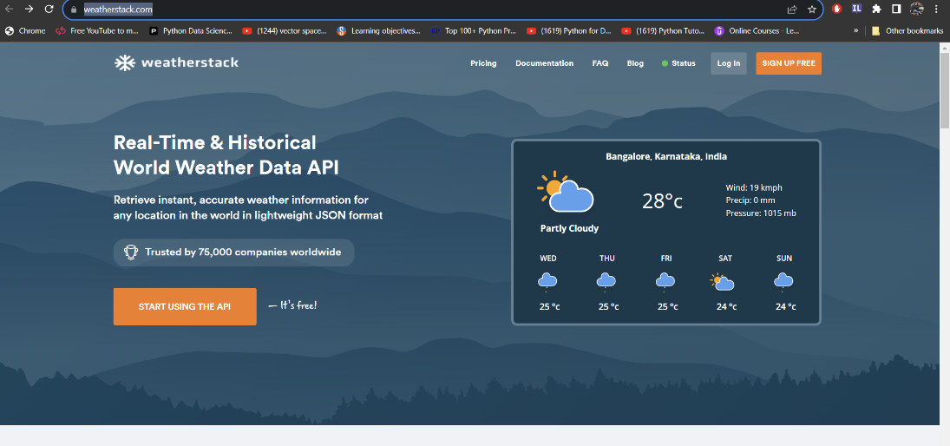

3. Select "SIGN UP FREE ACCOUNT"

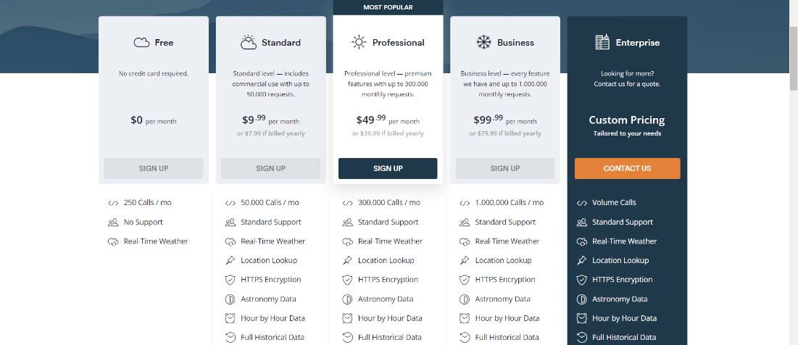

4. Navigate to your DASHBOARD

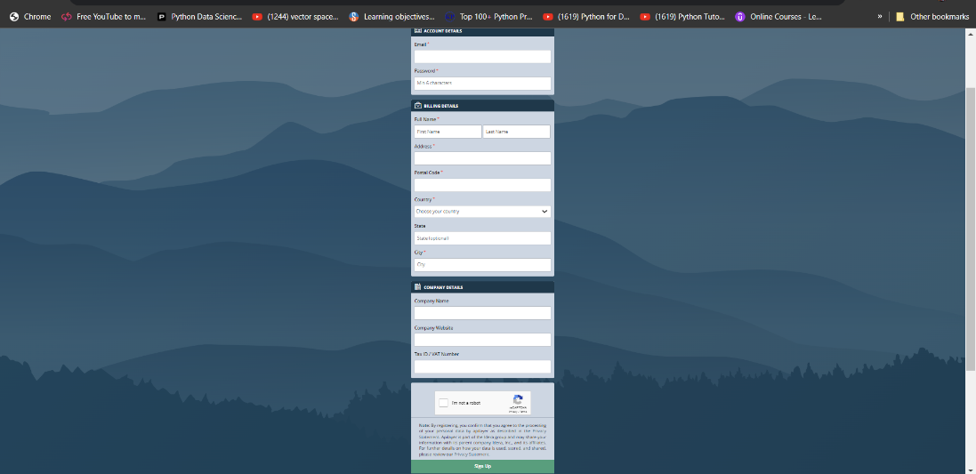

5. Your API ACCESS KEY WILL BE SHOWED THERE

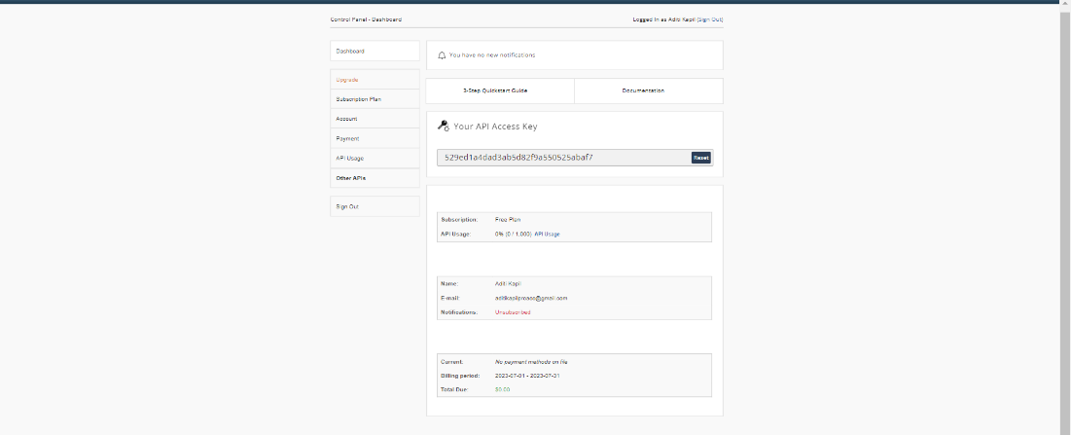

- Copy it and use it in the python code

- Twilio API: For sending SMS notifications.

Steps:
1. Visit: https://www.twilio.com/en-us

2. Login/sign up

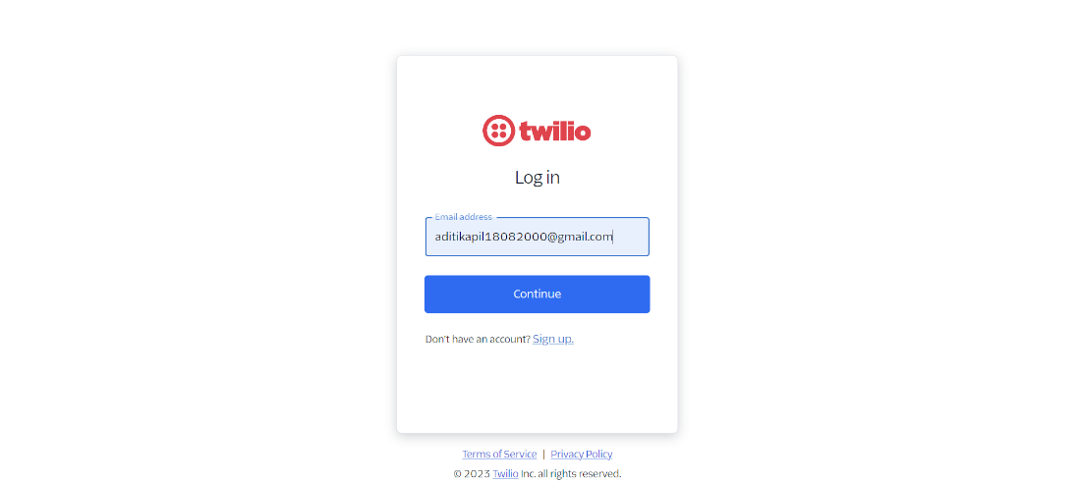

3. Your DASHBOARD will open

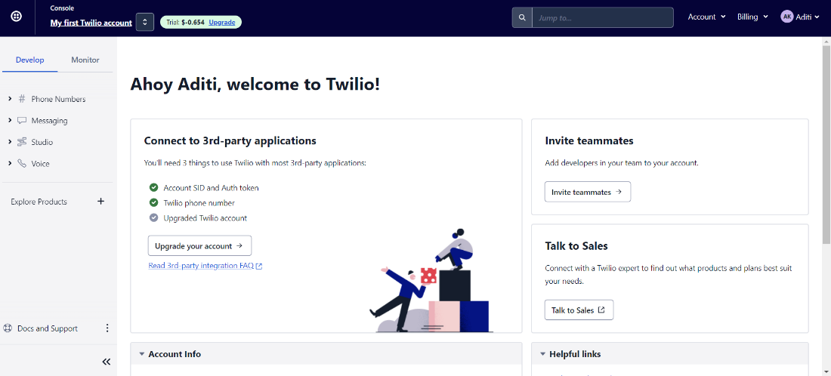

4. Navigate down, you will find account SID, Auth Token, My Twilio phone number

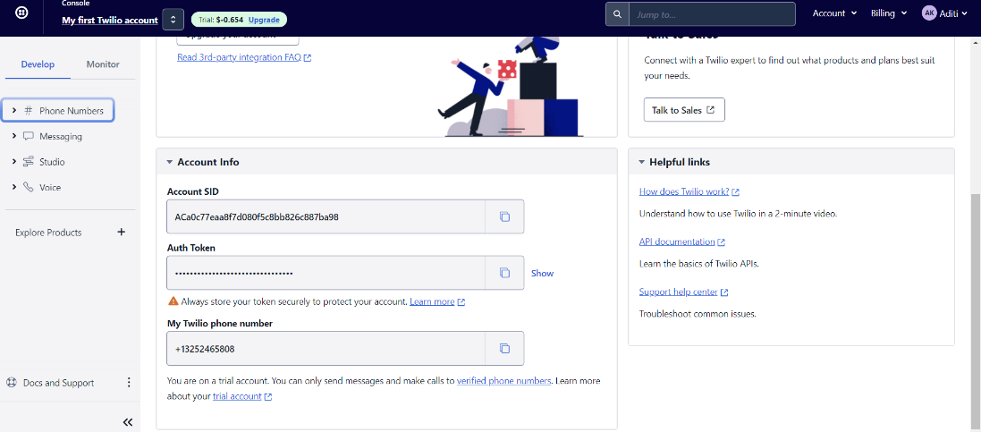

5. Copy and use them in python code for sending SMS
6. Remember, you can only send SMS to registered phone numbers
7. For that, click on " Phone Numbers" in left of DASHBOARD -> MANAGE -> Verified Caller IDs -> Register the numbers you want to send SMS to

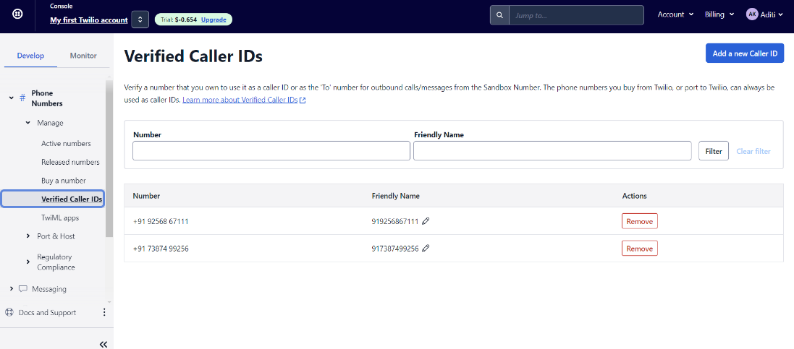

- Telegram Bot API: For sending Telegram notifications.

Steps:
1. Visit: Your Telegram App
2. Search for "BotFather"
3. send "/newbot" message
4. Enter a name for bot you want to create
5. Choose a username
6. Your bot will be created
7. Copy the API TOKEN given in last message of "BotFather"

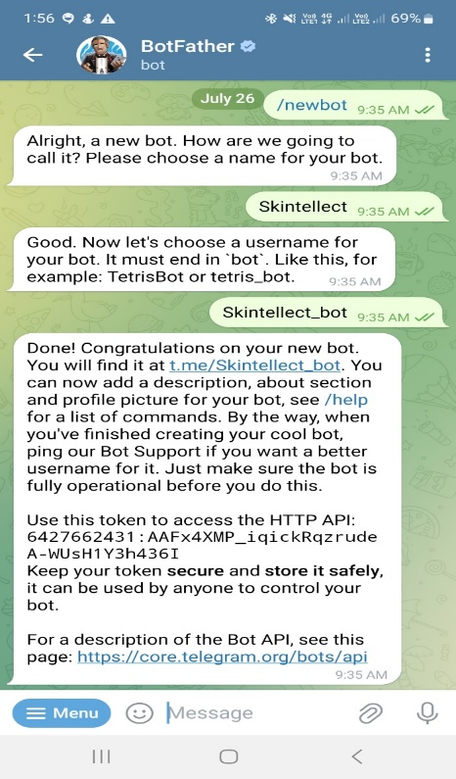

8. Start chatting with your bot (send a few messages)
9. Paste the API Token in python code file "getchat_id", run it
10. It will print the chat id
11. Copy the chat Id and paste it wherever asked

- OpenAI API: For generating personalized skincare recommendations

Steps:
1. Visit: https://openai.com/
2. Click on Sign in/Log in
3. Select "API"

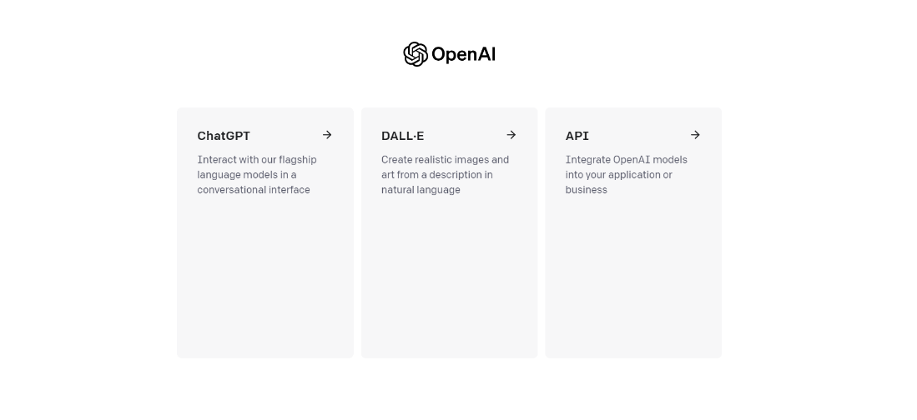

4. Your DASHBOARD will open
5. Click on "PERSONAL"
6. Select "View API keys"
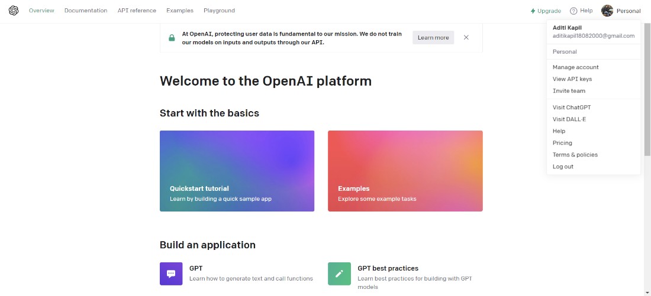

7. Copy API KEY given/ create yours and use it in your code

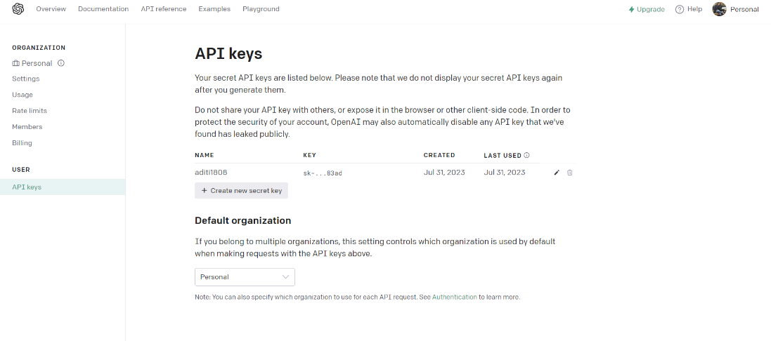

API Key Integration:

- In the relevant code files (`twilio_module.py`, `telegram_module.py`, `openai_module.py`), replace placeholder strings (e.g., 'YOUR_API_KEY', 'YOUR_TELEGRAM_BOT_TOKEN') with your actual API keys.

MQTT Broker Setup:

8. Install and Configure MQTT Broker:
- If you don't have an MQTT broker, consider using MQTTX or another suitable option.
- Install and configure the MQTT broker according to your machine's specifications.

9. Update Flask App Code:
- In the `app.py` file, ensure the MQTT broker's address and port are correctly set in the `broker_address` and `broker_port` variables.

Web Frontend and UI Customization:

10. Frontend Customization:
- Customize the web frontend using HTML, CSS, and JavaScript files in the `templates`(should be under Python folder) directory.
- Modify the layout, styles, and UI components to match your preferences.

Email Configuration:

12. Email Settings:
- If using Gmail for sending emails:
- Replace `sender_email` and `sender_password` placeholders in the `email_module.py` file with your Gmail credentials.
- Adjust the email configuration if you're using a different email provider.

Final Configuration:

13. Adjust Paths and Parameters:
- Update paths, filenames, and other parameters in the code to match your machine's directory structure and configuration.

Running the Application:

14. Start Flask App:
- Two flask web apps are being used in this project:
1. FOR ACCESSING SKINTELLECT
2. FOR ACCESSING IMAGE UPLOADED
- Open a terminal or command prompt.
- Navigate to the project directory.
- Activate the virtual environment if you created one.
- Run the Flask apps: python app.py(port number: 5000) and cam_app.py(port number: 5001)
- The apps will start, and you'll see output indicating that it's running, likely something like
"Running on http://127.0.0.1:5000/".

15. Access the Application:
- Open a web browser and enter the URL shown in the output (e.g., http://127.0.0.1:5000/) to access the SKINTELLECT application.

16. Use the Application:
- On the web interface, enter your email address, phone number, gender, and age.
- Interact with the ultrasonic sensor to trigger the display of information on the OLED screen based on user proximity.
- The W5300-MQTT-CAM device will capture your facial image, and the system will process the image to analyse various skin attributes.
- The personalized skincare recommendations will be sent to your email and phone number via SMS. Additionally, a notification will be sent to your Telegram app.

Important Considerations:

- Ensure all APIs, services, and devices are set up and functioning correctly before running the code.
- Implement data handling and security measures to protect user information and comply with relevant data privacy regulations.

By following these comprehensive steps, you can successfully set up and run the SKINTELLECT application on a different machine, complete with the ultrasonic sensor and Adafruit OLED screen integration, hardware setup, software configuration, and API integrations. This detailed guide ensures a seamless process for analysing skin attributes and providing personalized skincare recommendations.

CODE EXPLANATION
FILE NAME: index.html

<!DOCTYPE html>
<html>
<head>
<!-- Set the initial viewport configuration -->
<meta name="viewport" content="width=device-width, initial-scale=1.0">

<!-- Set the title of the webpage -->
<title>SKINTELLECT</title>
<!-- Define the CSS styles for the webpage -->
<style>
/* Styling for the body and header */
body {
font-family: Arial, sans-serif;
background-color: #f0f0f0;
margin: 0;
padding: 0;
}
/* Styling for the header section */
header {
background-color: #007bff;
color: #fff;
padding: 20px;
text-align: center;
}
/* Styling for the main heading */
h1 {
margin: 0;
font-size: 48px;
letter-spacing: 2px;
text-transform: uppercase;
font-weight: bold;
text-shadow: 2px 2px 4px rgba(0, 0, 0, 0.3);
}
/* Styling for the subheading */
h2 {
margin: 0;
font-size: 24px;
letter-spacing: 1px;
font-weight: bold;
}
/* Styling for regular paragraphs */
p {
font-size: 18px;
max-width: 600px;
margin: 20px auto;
}
/* Styling for the main content container */
.container {
text-align: center;
}
/* Styling for the submit button */
#submit-btn {
display: block;
margin: 0 auto;
background-color: #007bff;
color: #fff;
border: none;
padding: 12px 20px;
font-size: 16px;
cursor: pointer;
border-radius: 4px;
transition: background-color 0.3s ease;
}
/* Styling for submit button hover effect */
#submit-btn:hover {
background-color: #0056b3;
}
/* Styling for text areas */
textarea {
width: 300px;
height: 50px;
display: block;
margin: 20px auto;
resize: none;
}
/* Media Queries for responsive design */
@media (max-width: 768px) {
/* Adjust font sizes and padding for mobile view */
h1 {
font-size: 36px;
}
h2 {
font-size: 20px;
}
p {
font-size: 16px;
}
header {
padding: 10px;
}
}
/* Media Query for larger screens, e.g., tablets */
@media (min-width: 768px) and (max-width: 1024px) {
/* Adjust font sizes for tablet view */
h1 {
font-size: 42px;
}
h2 {
font-size: 22px;
}
}
</style>
</head>
<body>
<!-- Header section with title and subheading -->
<header>
<h1>SKINTELLECT</h1>
<h2>Intelligent Skin Analysis</h2>
</header>

<!-- Main content container -->
<div class="container">
<!-- Welcome message and instructions for users -->
<p>Welcome to SKINTELLECT!<br>Click the button below to start the skin analysis process.</p>
<!-- Text areas for user input -->
<textarea type="text" id="phone-number" rows="2" cols="40" placeholder="Enter your phone number along with country code"></textarea>
<textarea id="text" rows="2" cols="40" placeholder="Please enter a valid email id"></textarea>
<!-- Additional text areas for gender and age input -->
<textarea type="text" id="gender" rows="2" cols="40" placeholder="Enter your gender"></textarea>
<textarea type="text" id="age" rows="2" cols="40" placeholder="Enter your age"></textarea>
</div>
<!-- Container for the submission button -->
<div>
<!-- Button to trigger data submission -->
<button id="submit-btn" onclick="publishText()">Start Analysis</button>
</div>
<!-- Include jQuery library for AJAX functionality -->
<script src="https://code.jquery.com/jquery-3.6.0.min.js"></script>
<script>
// Function to send user data to the server
function publishText() {
// Get values from input fields
var text = document.getElementById('text').value; // Get email input
var phoneNumber = document.getElementById('phone-number').value; // Get phone number input
var gender = document.getElementById('gender').value; // Get gender input
var age = document.getElementById('age').value; // Get age input
// AJAX request to the server
$.ajax({
url: '/mqtt-publish', // Server endpoint
type: 'POST', // HTTP method
data: {
text: text,
'phone-number': phoneNumber,
gender: gender, // Send gender
age: age // Send age
},
success: function(response) { // On success
console.log(response); // Log server response
showAlert('Note: Please stand closer to the camera to capture a picture of your face'); // Show alert message
},
error: function(error) { // On error
console.error(error); // Log error
}
});
}

// Function to display an alert message
function showAlert(message) {
alert(message); // Show alert with the provided message
}
</script>
</body>
</html>

WHAT THIS FILE CONTAINS (IN SHORT):

The HTML code establishes the user interface for the SKINTELLECT web application. It features a responsive design with a dynamic header displaying the title "SKINTELLECT" and a subheading "Intelligent Skin Analysis." Users are prompted to input their email, phone number, gender, and age. Upon clicking the "Start Analysis" button, the data is sent via AJAX to the Flask app. The code also incorporates media queries for varied screen sizes and includes explanatory comments throughout the code for easy understanding of its components and functionalities.

FILE NAME: app.py

# Import required libraries
from flask import Flask, request, jsonify # Import Flask framework and other modules
import paho.mqtt.client as mqtt # Import MQTT client library
import WrinkleDetection # Import your custom WrinkleDetection module

# Create a Flask app instance
app = Flask(__name__) # Initialize the Flask app

# Initialize variables to store data
stored_text = "" # Variable to store entered text
stored_phone_number = "" # Variable to store phone number
stored_age = "" # Variable to store age
stored_gender = "" # Variable to store gender
response_text = "" # Variable to store MQTT response

# MQTT broker configuration
broker_address = "10.21.70.16" # MQTT broker's IP address
broker_port = 1883 # MQTT broker's port
mqtt_topic = "MQTT-CAM" # Topic for capturing images
response_topic = "CAM-MQTT" # Topic for receiving image analysis results

# Callback function when the client connects to the broker
def on_connect(client, userdata, flags, rc):
print("Connected with result code " + str(rc)) # Print connection result code
# Subscribe to the response topic
client.subscribe(response_topic) # Subscribe to MQTT response topic

# Callback function when a message is received from the broker
def on_message(client, userdata, msg):
global response_text # Use the global response_text variable
if msg.topic == response_topic:
new_response_text = msg.payload.decode('utf-8') # Decode MQTT message payload
if new_response_text.startswith("http://"):
response_text = new_response_text
# Process captured image using WrinkleDetection functions
finalmailid = WrinkleDetection.image_save(stored_text, response_text)
image_url = response_text
save_path = 'C:/Users/Aditi/OneDrive/Desktop/SkinTellect/'
WrinkleDetection.save_image_from_url(image_url, save_path)
wrinkles = WrinkleDetection.detect()
tone = WrinkleDetection.skin_tone_analysis()
contrastt = WrinkleDetection.skin_texture_analysis()
pig = WrinkleDetection.pigmentation_analysis()
WrinkleDetection.letdo(finalmailid, stored_phone_number, wrinkles, tone, contrastt, pig, stored_age, stored_gender)

# Create an MQTT client instance
client = mqtt.Client() # Create MQTT client instance

# Set the callback functions
client.on_connect = on_connect # Set on_connect callback
client.on_message = on_message # Set on_message callback

# Connect to the broker
client.connect(broker_address, broker_port) # Connect to MQTT broker

# Start the MQTT loop to handle incoming messages in the background
client.loop_start() # Start MQTT loop

# Define routes for the Flask app
@app.route('/') # Define route for the root URL
def index():
# Read and return the HTML file
with open('templates/index.html') as f:
return f.read() # Read and serve HTML file

@app.route('/mqtt-publish', methods=['POST']) # Define route for MQTT publish
def mqtt_publish():
global stored_text, stored_phone_number, stored_age, stored_gender # Use global variables
text = request.form.get('text') # Get 'text' field from form data
phone_number = request.form.get('phone-number') # Get 'phone-number' field from form data
stored_text = text # Store entered text
stored_phone_number = phone_number # Store phone number
stored_age = request.form.get('age') # Store age from form data
stored_gender = request.form.get('gender') # Store gender from form data

# Publish MQTT message to trigger image capture
client.publish(mqtt_topic, "cmd:capture") # Publish MQTT message

return jsonify({'message': 'Text, phone number, age, and gender saved successfully'}) # Return JSON response

@app.route('/get-stored-text', methods=['GET']) # Define route to get stored text
def get_stored_text():
global stored_text # Use global stored_text variable
return jsonify({'stored_text': stored_text}) # Return stored_text in JSON response

@app.route('/get-response-text', methods=['GET']) # Define route to get response text
def get_response_text():
global response_text # Use global response_text variable
return jsonify({'response_text': response_text}) # Return response_text in JSON response

# Run the Flask app
if __name__ == '__main__':
app.run(host="0.0.0.0", debug=True) # Run the app on 0.0.0.0 (all network interfaces) with debugging enabled

WHAT THIS FILE CONTAINS (IN SHORT):

This code is the backbone of the SKINTELLECT application, leveraging Flask and MQTT to capture facial images, analyze skin attributes, and provide personalized skincare recommendations. It establishes MQTT communication with a camera device, handles user inputs through Flask routes, and employs the WrinkleDetection module for image analysis. The app's core functionality lies in capturing user data, triggering image capture, processing the images, and delivering the analysis results, thereby offering users insightful skincare recommendations.

FILE NAME: wrinkleDetection.py

# Import required libraries and modules
import cv2 # OpenCV for image processing
import numpy as np # NumPy for numerical operations
from matplotlib import pyplot as plt # Matplotlib for visualization
from IPython.display import display, Image # IPython display for showing images
import requests # Requests library for making HTTP requests
import os # OS module for operating system-related functions

# Import the MTCNN face detection model
from mtcnn.mtcnn import MTCNN

# Import the 'combine' module for further processing
import combine

# Initialize variables to store analysis results
wrinkles = ""
tone = ""
contrastt = ""
diss = ""
pig = ""

# Initialize variables to store input data
stored_text = ""

# Function to save image path and response text
def image_save(stored_text2, response_text2):
global stored_text # Use the global variable
stored_text = stored_text2 # Store the input data
return stored_text # Return the stored data

# Initialize variables for image URL and save path
image_url = ""
save_path = ""

# Function to save an image from a given URL to a specified path
def save_image_from_url(image_url, save_path):
try:
# Send a GET request to the image URL
response = requests.get(image_url)
response.raise_for_status() # Check for any errors in the request

# Get the file name from the URL
file_name = os.path.basename(image_url)

# Combine the file name with the save_path to create the complete file path
file_path = os.path.join(save_path, "W5300-MQTT-CAM_pic.jpg")

# Save the image to the specified location
with open(file_path, 'wb') as file:
file.write(response.content)

return True # Image saved successfully

except Exception as e:
print(f"Error occurred: {e}")
return False # Image saving failed

# Load an image using OpenCV
img = cv2.imread("C:/Users/Aditi/OneDrive/Desktop/SkinTellect/W5300-MQTT-CAM_pic.jpg")

# Function to detect wrinkles on a face using edge detection
def detect():
# Load the pre-trained MTCNN face detector
detector = MTCNN()

# Detect faces in the image using MTCNN
faces = detector.detect_faces(img)

# Check if any faces were detected
if len(faces) > 0:
for face in faces:
x, y, w, h = face['box']

# Crop the face region
face_region = img[y:y+h, x:x+w]

# Convert the face region to grayscale
gray_face = cv2.cvtColor(face_region, cv2.COLOR_BGR2GRAY)

# Apply Canny edge detection on the grayscale face region
edges = cv2.Canny(gray_face, 130, 1000)

# Count the number of edges in the cropped face region
num_edges = np.count_nonzero(edges)

if num_edges > 1000:
return "wrinkles found" # Wrinkles detected
else:
return "wrinkles not found" # No wrinkles detected

else:
return "No face detected" # No face detected in the image

# Function to analyze skin tone based on LAB color space
def skin_tone_analysis():
# Convert the image from BGR to RGB color space
img_rgb = cv2.cvtColor(img, cv2.COLOR_BGR2RGB)

# Convert the RGB image to LAB color space
img_lab = color.rgb2lab(img_rgb)

# Extract the L*, a*, and b* channels
l_channel, a_channel, b_channel = cv2.split(img_lab)

# Calculate the mean a* and b* values
mean_a = np.mean(a_channel)
mean_b = np.mean(b_channel)

# Calculate the skin tone index (STI)
sti = np.sqrt(mean_a ** 2 + mean_b ** 2)

# Determine the skin tone category based on the STI value
if sti < 20:
skin_tone_category = "Dark skin"
elif sti < 40:
skin_tone_category = "Medium skin"
else:
skin_tone_category = "Light skin"

return skin_tone_category

# Function to analyze skin texture using GLCM properties
def skin_texture_analysis():
# Convert the image to grayscale
gray_img = cv2.cvtColor(img, cv2.COLOR_BGR2GRAY)

# Calculate the GLCM with specific properties (contrast and dissimilarity)
glcm = greycomatrix(gray_img, [1], [0], 256, symmetric=True, normed=True)
contrast = greycoprops(glcm, 'contrast')[0, 0]
dissimilarity = greycoprops(glcm, 'dissimilarity')[0, 0]

return contrast, dissimilarity # Return the texture analysis results

# Function to analyze pigmentation in the image
def pigmentation_analysis():
# Convert the image from BGR to HSV color space
img_hsv = cv2.cvtColor(img, cv2.COLOR_BGR2HSV)

# Define the lower and upper bounds of pigmented color in HSV
lower_bound = np.array([0, 50, 50]) # Lower bound for hue (red)
upper_bound = np.array([20, 255, 255]) # Upper bound for hue (yellow)

# Create a mask to isolate pigmented regions
mask = cv2.inRange(img_hsv, lower_bound, upper_bound)

# Count the number of pigmented pixels
pigmented_pixels = np.sum(mask == 255)

# Calculate the total number of pixels in the image
total_pixels = mask.shape[0] * mask.shape[1]

# Calculate the percentage of pigmented pixels in the image
pigmentation_percentage = (pigmented_pixels / total_pixels) * 100

return pigmentation_percentage

# Main function to perform all analyses and call 'combine' module
def letdo(finalmailid, ph_no, wrinkles, tone, contrastt, pig, age, gender):
# Determine skin texture properties
contrast, dissimilarity = skin_texture_analysis()

# Determine skin tone category
skin_tone = skin_tone_analysis()

# Check and display if wrinkles are detected
wrinkle_result = detect()

# Call 'combine' module to process and combine results
combine.var(finalmailid, ph_no, wrinkle_result, skin_tone, contrast, pig, age, gender)

WHAT THIS FILE CONTAINS (IN SHORT):

The code is a Python script that employs OpenCV, NumPy, and other libraries for analyzing facial images in various ways. It includes functions to detect wrinkles on a face using edge detection, assess skin tone through LAB color space analysis, evaluate skin texture using GLCM properties, and identify pigmentation in the image. The script also interacts with the 'combine' module for further processing and analysis of the collected data. The code's modularity and well-commented sections make it easy to understand and modify for tailored image analysis applications.

FILE NAME: combine.py

import temp # Importing the 'temp' module
import recommend # Importing the 'recommend' module

# Define a function named 'var' that takes various parameters
def var(finalmailid, ph_no, wrinkles, tone, contrastt, pig, age, gender):
result_text = "" # Initialize an empty string to store the result text
final_mail_id = finalmailid # Assign the provided email ID to the variable 'final_mail_id'
gender = gender # Assign the provided gender to the variable 'gender'
age = age # Assign the provided age to the variable 'age'

# Append the values with labels to the 'result_text' variable
result_text += "Gender: " + str(gender) + "\n"
result_text += "Age: " + str(age) + "\n"
result_text += "Wrinkles: " + str(wrinkles) + "\n"
result_text += "Skin Tone: " + str(tone) + "\n"
result_text += "Skin Contrast: " + str(contrastt) + "\n"
result_text += "Skin Pigmentation: " + str(pig) + "\n"

# Call the 'temp.temp_hum' function from the 'temp' module
# Pass the 'result_text', 'final_mail_id', and 'ph_no' as parameters
temp.temp_hum(result_text, final_mail_id, ph_no)

WHAT THIS FILE CONTAINS (IN SHORT):

This code defines a function named 'var' that takes several parameters, including the user's email ID, phone number, analysis results (wrinkles, skin tone, contrast, pigmentation, age, and gender). It assembles these values with appropriate labels into a text string called 'result_text'. The function then calls another function 'temp.temp_hum' from the 'temp' module, passing the assembled result text, final email ID, and phone number as arguments. This function likely involves temperature and humidity handling, but specific details would be found in the 'temp' module.

FILE NAME: temp.py

import recommend # Importing the 'recommend' module

# Define a function named 'temp_hum' that takes three parameters
def temp_hum(result_text, final_mail_id, ph_no):
import requests # Importing the 'requests' library for making API requests

# Replace 'YOUR_API_KEY' with your actual Weatherstack API key
api_key = '529ed1a4dad3ab5d82f9a550525abaf7'

# Replace 'YOUR_CITY' with the city name for which you want to get weather data
city = 'pune' # Assuming it is installed in Pune

# API endpoint URL with API key and city
url = f'http://api.weatherstack.com/current?access_key={api_key}&query={city}'

# Send API request and get response data
response = requests.get(url)
data = response.json() # Parse the response JSON data

# Check if the API request was successful
if response.status_code == 200:
# Extract temperature and humidity data from the response
temperature = data['current']['temperature']
humidity = data['current']['humidity']

# Append temperature and humidity information to the 'result_text' variable
result_text += "Temperature of place: " + str(temperature) + "\n"
result_text += "Humidity of place: " + str(humidity) + "\n"

# Call the 'recommend.recommend_chat' function from the 'recommend' module
# Pass the 'result_text', 'final_mail_id', and 'ph_no' as parameters
recommend.recommend_chat(result_text, final_mail_id, ph_no)

else:
print('Failed to fetch weather data.')

WHAT THIS FILE CONTAINS (IN SHORT):

This code defines a function named 'temp_hum' that takes three parameters: 'result_text', 'final_mail_id', and 'ph_no'. It uses the 'requests' library to make an API request to the Weatherstack API to fetch current weather data for a specified city (in this case, Pune). If the API request is successful (status code 200), it extracts the temperature and humidity information from the response and appends it to the 'result_text' variable. Then, it calls the 'recommend.recommend_chat' function from the 'recommend' module, passing the assembled result text, final email ID, and phone number as arguments. If the API request fails, it prints a failure message.

FILE NAME: recommend.py

import openai # Importing the 'openai' library
import json # Importing the 'json' module
import mailsend # Importing the 'mailsend' module
import smsSend # Importing the 'smsSend' module

# Define a function named 'recommend_chat' that takes three parameters
def recommend_chat(result_text, final_mail_id, ph_no):
openai.api_key = "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" # Set OpenAI API key

# Declare the 'chat' variable to hold the input text for generating suggestions
chat = result_text

# Create a completion request to the OpenAI API
respond = openai.Completion.create(
model="text-davinci-003", # Specify the language model to use
prompt="""Take the chat and Based on the provided values, give detailed personalized skin care suggestions:
- suggest recommendation based on if wrinkles are found or not
- suggest recommendation based on temperature and humidity of place user lives in
- suggest recommendation based on contrast of skin whether low, medium, high
- suggest recommendation based on pigmentation of skin found low, medium, high
- suggestions should be purely based on temperature and humidity taking into consideration

Text: """ + chat + """

""",
temperature=0, # Set the temperature for randomness (0 means deterministic)
max_tokens=1000, # Set the maximum number of tokens in the response
top_p=1, # Set the nucleus sampling probability
frequency_penalty=0.2, # Set the frequency penalty
presence_penalty=0 # Set the presence penalty
)

# Extract the generated text from the API response
generated_text = respond.choices[0].text.strip()

# Display the generated text as output
print(generated_text)

# Call the 'send_mailToCustomer' function from the 'mailsend' module
# Pass the 'final_mail_id', 'result_text', and 'generated_text' as parameters
mailsend.send_mailToCustomer(final_mail_id, result_text, generated_text)

# Call the 'send_sms' function from the 'smsSend' module
# Pass the 'ph_no', 'result_text', and 'generated_text' as parameters
smsSend.send_sms(ph_no, result_text, generated_text)

WHAT THIS FILE CONTAINS (IN SHORT):

This code defines a function named 'recommend_chat' that takes three parameters: 'result_text', 'final_mail_id', and 'ph_no'. Inside the function, it sets the OpenAI API key, creates a completion request to the OpenAI API using the 'openai.Completion.create' method, and provides a prompt containing the input 'chat'. The generated text is extracted from the API response and displayed. Then, the 'send_mailToCustomer' function from the 'mailsend' module is called, passing the final email ID, result text, and generated text as arguments. Similarly, the 'send_sms' function from the 'smsSend' module is called, passing the phone number, result text, and generated text as arguments.

FILE NAME: smsSend.py

def send_sms(ph_no, result_text, recommendation):
# Import the 'Client' class from the 'twilio.rest' module
from twilio.rest import Client

# Concatenate the result text and recommendation for the SMS body
final_text = result_text + "\n" + "\n" + recommendation

# Set your Twilio Account SID and Auth Token
SID = 'ACa0c77eaa8f7d080f5c8bb826c887ba98'
AUTH_TOKEN = 'd0effba4995c97f648caa1bc97e316a0'

# Create a Twilio Client instance using your SID and Auth Token
cl = Client(SID, AUTH_TOKEN)

# Send an SMS using the 'messages.create' method of the Twilio Client
cl.messages.create(body=final_text, from_='+13252465808', to=ph_no)

# Print a success message
print("SMS SENT SUCCESSFULLY ! ")

WHAT THIS FILE CONTAINS (IN SHORT):

This code defines a function named 'send_sms' that takes three parameters: 'ph_no' (phone number), 'result_text', and 'recommendation'. Inside the function, it imports the 'Client' class from the 'twilio.rest' module. Then, it concatenates the 'result_text' and 'recommendation' to form the body of the SMS. The Twilio Account SID and Auth Token are set as variables. A Twilio Client instance is created using the SID and Auth Token. The 'messages.create' method of the Twilio Client is used to send an SMS, specifying the body, sender's phone number, and recipient's phone number ('ph_no'). Finally, a success message is printed.

FILE NAME: mailsend.py

import smtplib
from email.mime.text import MIMEText
from email.mime.multipart import MIMEMultipart
from google.oauth2.credentials import Credentials
from google_auth_oauthlib.flow import InstalledAppFlow
from email.mime.image import MIMEImage
import requests

# Telegram Bot token and chat ID for sending notifications
telegram_bot_token = '6427662431:AAFx4XMP_iqickRqzrudeA-WUsH1Y3h436I'
telegram_chat_id = '6119638322'

def send_telegram_notification(message):
# Construct the Telegram API URL
telegram_api_url = f"https://api.telegram.org/bot{telegram_bot_token}/sendMessage"

# Data for sending the message
data = {
"chat_id": telegram_chat_id,
"text": message,
}

# Send the message using the requests library
response = requests.post(telegram_api_url, data=data)
return response.json()

def send_mailToCustomer(stored_text, found, recommendations):
# Email sender's credentials
sender_email = "aditi.kapil@msds.christuniversity.in"
sender_password = "ornimint123"

# Receiver's email is passed as 'stored_text'
receiver_email = stored_text

# Email subject and body
subject = "SKINTELLECT 📑 Your report is ready report !!! "
body = f"{found}\n\n{recommendations}"

# Path to the image to be attached
image_path = 'W5300-MQTT-CAM_pic.jpg'

# Create a message container (multipart/alternative represents text and HTML formats)
message = MIMEMultipart()
message["From"] = sender_email
message["To"] = receiver_email
message["Subject"] = subject

# Attach the plain text body to the message
message.attach(MIMEText(body, 'plain'))

# Attach the image as an attachment to the message
with open(image_path, 'rb') as fp:
img = MIMEImage(fp.read())
img.add_header('Content-Disposition', 'attachment', filename=image_path)
message.attach(img)

try:
# Connect to the Gmail SMTP server securely
server = smtplib.SMTP_SSL('smtp.gmail.com', 465)

# Log in to the sender's email account
server.login(sender_email, sender_password)

# Send the email
server.sendmail(sender_email, receiver_email, message.as_string())

print("Email sent successfully!")

# Send a Telegram notification
send_telegram_notification("SKINTELLECT 📑 Another report generated!")

except Exception as e:
print("Error: ", e)

finally:
# Close the connection to the server
server.quit()

WHAT THIS FILE CONTAINS (IN SHORT):

This code defines the send_mailToCustomer function that takes stored_text, found, and recommendations as input. Inside the function, it uses the Gmail SMTP server to send an email with the provided data. It also attaches the image 'W5300-MQTT-CAM_pic.jpg'. The send_telegram_notification function is used to send a notification to a Telegram chat using the provided telegram_bot_token and telegram_chat_id.

FILE NAME: botchatid.py

import requests

# Replace 'YOUR_TELEGRAM_BOT_TOKEN' with your actual Telegram bot token
telegram_bot_token = '6427662431:AAFx4XMP_iqickRqzrudeA-WUsH1Y3h436I'

def get_chat_id():
# Construct the Telegram API URL for getting updates
telegram_api_url = f"https://api.telegram.org/bot{telegram_bot_token}/getUpdates"

# Send a GET request to the Telegram API
response = requests.get(telegram_api_url)

# Parse the JSON response
data = response.json()

if "result" in data and data["result"]:
# Assuming the latest message is the most recent one, get the chat ID from it
chat_id = data["result"][-1]["message"]["chat"]["id"]
return chat_id
else:
raise ValueError("Failed to retrieve chat ID. Make sure your bot has received messages.")

if __name__ == "__main__":
try:
# Call the function to get the chat ID
chat_id = get_chat_id()
print("Chat ID:", chat_id)
except Exception as e:
print("Error:", e)

WHAT THIS FILE CONTAINS (IN SHORT):

This code defines a get_chat_id function that retrieves the chat ID from the latest message received by the Telegram bot. It constructs the Telegram API URL using the provided telegram_bot_token, sends a GET request, and then parses the JSON response to extract the chat ID. The extracted chat ID is printed in the if __name__ == "__main__": block when the script is run.

FILE NAME: skintellect2.ino

#include <Ethernet.h>
#include <Wire.h>
#include <SoftWire.h>
// MQTT [[
#include <PubSubClient.h>
// ]]
#include <ArduinoJson.h>
#include "HardwareSerial.h"
#include <Adafruit_GFX.h>
#include <Adafruit_SSD1306.h>
#include "qrcodegen.h"
const char* device_unique_id = "ArdCam1_" __DATE__ "_" __TIME__;

// #define SERIAL_OUTPUT
#ifdef SERIAL_OUTPUT
#define PRINT(x) Serial.print(x)
#define PRINTLN(x) Serial.println(x)
#else
#define PRINT(x)
#define PRINTLN(x)
#endif

#define SYNC 0x96

int trigPin = 11; // TRIG pin
int echoPin = 12;
float duration_us, distance_cm;

#define PIN0_SDA 14
#define PIN0_SCL 15

#define SCREEN_WIDTH 128
#define SCREEN_HEIGHT 64
#define OLED_RESET -1
#define SCREEN_ADDRESS 0x3C

Adafruit_SSD1306 display(SCREEN_WIDTH, SCREEN_HEIGHT, &Wire, OLED_RESET);

// Enter a MAC address and IP address for your controller below.
// The IP address will be dependent on your local network:
byte mac[] = {
0xDE, 0xAD, 0xBE, 0xEF, 5, 0xF7
};
IPAddress ip(192, 168, 0, 77);
//IPAddress ip(10, 5, 15, 109);

// Enter the IP address of the server you're connecting to:
//IPAddress http_server(192, 168, 0, 107);
//IPAddress http_server(10, 21, 70, 16);
const char *http_server = "10.21.70.16";
IPAddress myDns(192, 168, 0, 1);
uint16_t port = 5000;

// Initialize the Ethernet client library
// with the IP address and port of the server
// that you want to connect to (port 23 is default for telnet;
// if you're using Processing's ChatServer, use port 10002):
#define max_transfer 1024
#define max_buffer (100 * max_transfer)
byte img_buf[max_buffer];
EthernetClient client;

//[ MQTT
IPAddress mqtt_server(10, 21, 70, 16);
// IPAddress mqtt_server(44, 195, 202, 69);
EthernetClient mqttClient;
PubSubClient mqtt_client(mqttClient);
bool capture_requested = 0;
//]

//===================================================================================================
// HTTP POST

int count = 0;
char c = 0;

void client_write_large(byte *bptr, size_t len) {
size_t sent = 0;
for (; sent + max_transfer < len; ) {
client.write(bptr, max_transfer);
sent += max_transfer;
bptr += max_transfer;
//PRINTLN(max_transfer);
}
client.write(bptr, len - sent);

PRINT("Sent: "); PRINTLN(len);
}

void httpPostForm(byte *imageData, uint32_t imageSize) {
String textData = "OpenMVCam1"; // Replace with your text data

// Prepare the POST request body
String requestBody = "";
// Append the text data
requestBody += "--ArduinoBoundary_OpenMVCam1\r\n";
requestBody += "Content-Disposition: form-data; name=\"text\"\r\n\r\n";
requestBody += textData;
// Append the image data
requestBody += "\r\n--ArduinoBoundary_OpenMVCam1\r\n";
requestBody += "Content-Disposition: form-data; name=\"image\"; filename=\"image.jpg\"\r\n\r\n";

//requestBody.append(imageData, imageSize);

// Append the closing boundary
String requestBodyEnd = "";
requestBodyEnd += "\r\n--ArduinoBoundary_OpenMVCam1--\r\n";

// Prepare the POST request headers
String requestHeaders = "POST /upload HTTP/1.1\r\n";
requestHeaders += "Host: ";
requestHeaders += http_server;
requestHeaders += ":";
requestHeaders += port;
requestHeaders += "\r\n";
requestHeaders += "Content-Type: multipart/form-data; boundary=ArduinoBoundary_OpenMVCam1\r\n";
requestHeaders += "Connection: close\r\n";
requestHeaders += "Content-Length: " + String(requestBody.length()+imageSize+requestBodyEnd.length()) + "\r\n\r\n";

// Send the POST request headers
client.print(requestHeaders);

// Send the POST request body
client.print(requestBody);
client_write_large(imageData, imageSize);
client.print(requestBodyEnd);
client.flush();

delay(100);
}

void http_postData(byte *buf, uint32_t length) {
count = 0;

// if the server's disconnected, reconnect the client:
while (!client.connected()) {
PRINTLN();
PRINTLN("disconnected. Reconnecting...");
if (client.connect(http_server, port)) {
PRINTLN("connected");
break;
} else {
// if you didn't get a connection to the server:
if (++count > 5) { // Retry 5 times.
PRINTLN("HTTP Post failed. Give up.");
return;
}
PRINTLN("connection failed");
delay(1000);
}
}
delay(200);

httpPostForm(buf, length);

int len = client.available();

String msg = "HTTP Response: ";
msg += len;
//mqtt_client.publish("W5300-MQTT", msg.c_str());

if (len > 0) {
byte buffer[500];
if (len > 500) len = 500;
int recvlen = 0;

recvlen = client.read(buffer+recvlen, len);
if (recvlen < len) {
delay(10);
recvlen += client.read(buffer+recvlen, len-recvlen);
}

String msg = "HTTP Received: ";
msg += recvlen;
//mqtt_client.publish("W5300-MQTT", msg.c_str());

//Serial.write(buffer, len); // show in the serial monitor (slows some boards)
//PRINTLN("");
//byteCount = byteCount + len;

byte prev_char = 0;
String response = "";
int index = 0;
for (index=0; index<len; ++index) {
if (buffer[index] == '\n') {
if (prev_char == '\n')
break;
} else if (buffer[index] == '\r')
continue;
prev_char = buffer[index];
}

for (; index<len; ++index)
response += (char)buffer[index];
response.trim();

PRINTLN("Contents: " + response);
mqtt_client.publish("W5300-MQTT", response.c_str());
}

client.stop();
}

//===================================================================================================
// MQTT [[

void callback(char* topic, byte* payload, unsigned int length) {
PRINT(">>>>>>>>>>> Message arrived [");
PRINT(topic);
PRINT("] ");
String cmd = "";
for (int i=0;i<length;i++) {
cmd += (char)payload[i];
PRINT((char)payload[i]);
}
PRINTLN();

if (cmd == "cmd:capture") {
capture_requested = 1;
PRINTLN("Capture requested!!!");
}
}

void reconnect() {
// Loop until we're reconnected
while (!mqtt_client.connected()) {
PRINT("MQTT: Attempting MQTT connection...");
// Attempt to connect
if (mqtt_client.connect(device_unique_id)) {
PRINTLN("MQTT: connected");
mqtt_client.publish("W5300-MQTT", "Ready");
// ... and resubscribe
mqtt_client.subscribe("MQTT-W5300");
} else {
PRINT("MQTT: failed, rc=");
PRINT(mqtt_client.state());
PRINTLN(" MQTT: try again in 5 seconds");
// Wait 5 seconds before retrying
delay(2000);
}
}
}
// ]]

//===================================================================================================

void setup() {
// Open serial communications and wait for port to open:
Serial3.setRx(PC11);
Serial3.setTx(PC10);
delay(50);

// Open serial communications and wait for port to open:
#ifdef SERIAL_OUTPUT
Serial.begin(9600);
#else
Serial.setRx(0);
Serial.setTx(1);
//Serial.begin(1000000);
Serial.begin(500000);
//Serial.begin(38400);
//Serial.begin(19200);
delay(50);
#endif

pinMode(trigPin, OUTPUT);
pinMode(echoPin, INPUT);

while (!Serial) {
; // wait for serial port to connect. Needed for native USB port only
}

// start the Ethernet connection:
PRINTLN("Initialize Ethernet with DHCP:");
if (Ethernet.begin(mac) == 0) {
PRINTLN("Failed to configure Ethernet using DHCP");
// Check for Ethernet hardware present
if (Ethernet.hardwareStatus() == EthernetNoHardware) {
PRINTLN("Ethernet shield was not found. Sorry, can't run without hardware. :(");
while (true) {
delay(1); // do nothing, no point running without Ethernet hardware
}
}
if (Ethernet.linkStatus() == LinkOFF) {
PRINTLN("Ethernet cable is not connected.");
}
// try to congifure using IP address instead of DHCP:
Ethernet.begin(mac, ip, myDns);
} else {
PRINT(" DHCP assigned IP ");
PRINTLN(Ethernet.localIP());
}

Wire.setSDA(PIN0_SDA);
Wire.setSCL(PIN0_SCL);

if (!display.begin(SSD1306_SWITCHCAPVCC, SCREEN_ADDRESS)) {
for (;;) ;
}
display.display();
delay(1000);
display.clearDisplay();

// give the Ethernet shield a second to initialize:

// MQTT [[
mqtt_client.setServer(mqtt_server, 1883);
mqtt_client.setCallback(callback);
// ]]

// give the Ethernet shield a second to initialize:
delay(500);

}

unsigned long prevmillis = 0;
uint8_t qrcode[qrcodegen_BUFFER_LEN_MAX];
uint8_t tempBuffer[qrcodegen_BUFFER_LEN_MAX];
int prevstat = -1;

void loop() {
digitalWrite(trigPin, LOW);
delayMicroseconds(2);
digitalWrite(trigPin, HIGH);
delayMicroseconds(10);
digitalWrite(trigPin, LOW);

// measure duration of pulse from ECHO pin
duration_us = pulseIn(echoPin, HIGH);

// calculate the distance
distance_cm = duration_us / 29 / 2;

// Check if someone is within 100 cm range
if (distance_cm < 100 && distance_cm > 0) { // Check if distance is within the valid range (0 to 100 cm)
// Display the image on the OLED screen
if (prevstat != 0) {
display.clearDisplay();
//display.setCursor(34, 0);
bool ok = genQR("http://192.168.0.102:5000/", tempBuffer, qrcode);
if (ok) {
drawQR(34, 0, qrcode);
}
prevstat = 0;
debounce = 0;
}
} else {
if (prevstat != 1) {
display.clearDisplay();
display.setTextSize(1);
display.setTextColor(SSD1306_WHITE);
display.setCursor(20, 5);
display.print(F("Try Skintellect!!"));
display.display();
prevstat = 1;
}
}

//*// MQTT [[
if (!mqtt_client.connected()) {
reconnect();
}
mqtt_client.loop();
// ]]
//*/

//if (millis() - prevmillis > 5000)
if (capture_requested) {
capture_requested = 0;

// Flush serial buffer.
while (Serial.available())
Serial.read();

// Send SYNC code
Serial.write(SYNC);

uint32_t length = serial_read_length();
if (length > 0) {
String response = "Length: ";
response += length;
mqtt_client.publish("W5300-MQTT", response.c_str());

uint32_t received = serial_read_data(img_buf, length);
if (received != length) {
// Time-out error!!!!
String response = "Time-out: "; // + received;
response += received;
mqtt_client.publish("W5300-MQTT", response.c_str());
} else {
// Send it to the server
String response = "Image received: "; // + length;
mqtt_client.publish("W5300-MQTT", response.c_str());
http_postData(img_buf, length);
}
} else {
mqtt_client.publish("W5300-MQTT", "No data");
}
}
}
bool genQR(const char* text, uint8_t* buf, uint8_t* qrcode) {
bool ret = qrcodegen_encodeText(text, buf, qrcode, qrcodegen_Ecc_LOW,
//qrcodegen_VERSION_MIN, qrcodegen_VERSION_MAX, qrcodegen_Mask_AUTO, true);
3, 3, qrcodegen_Mask_AUTO, true);

return ret;
}

void drawQR(int xinit, int yinit, uint8_t* qrcode) {
int size = qrcodegen_getSize(qrcode);
int scale = SCREEN_HEIGHT / size;
display.clearDisplay();
for (int y = 0; y < size; y++) {
for (int x = 0; x < size; x++) {
if (qrcodegen_getModule(qrcode, x, y)) {
display.fillRect(xinit+x*scale, yinit+y*scale, scale, scale, SSD1306_WHITE);
}
}
}
display.display();
}
uint32_t serial_read_length() {
uint32_t length = 0;
byte recv[4];
int index = 0;

prevmillis = millis();
//Loop with 1sec timeout.
while (millis()-prevmillis < 1000) {
if (Serial.available()) {
// Read the most recent byte
recv[index++] = Serial.read();

if (index >= 4) {
// Big endian
length = (recv[0] << 24) | (recv[1] << 16) | (recv[2] << 8) | recv[3];
break;
}
}
}

return length;
}

uint32_t serial_read_data(byte *buf, uint32_t length) {
int index = 0;

uint32_t maxsize = 1024;
uint32_t recvlen = 0;
uint32_t remain = length;

prevmillis = millis();
while (remain > 0 && (millis()-prevmillis < 2000)) {
if (remain > maxsize) {
recvlen = serial_read_data0(buf, maxsize);
} else {
recvlen = serial_read_data0(buf, remain);
}
if (recvlen == -1) {
return length - remain;
}
buf += recvlen;
remain -= recvlen;

/*
String response = "RecvLen: ";
response += recvlen;
mqtt_client.publish("W5300-MQTT", response.c_str());
*/
}

return length - remain;
}

uint32_t serial_read_data0(byte *buf, uint32_t length) {
int index = 0;

prevmillis = millis();
//Loop with 2sec timeout.
while (millis()-prevmillis < 1000) {
if (Serial.available()) {
// Read the most recent byte
buf[index++] = Serial.read();

if (index >= length)
return index;
}
}

return -1;
}

WHAT THIS FILE CONTAINS (IN SHORT):

This code combines various functionalities such as ultrasonic distance measurement, QR code generation, Ethernet communication, MQTT (Message Queuing Telemetry Transport) communication, and serial communication:

1. Library Inclusions:
- Several libraries are included at the beginning of the code, such as Ethernet, Wire (for I2C communication), PubSubClient (for MQTT communication), ArduinoJson (for JSON manipulation), Adafruit_GFX (for graphics functions), Adafruit_SSD1306 (for OLED display control), and qrcodegen (for QR code generation).

2. Global Variables and Constants:
- `device_unique_id`: A unique identifier for the device, likely combining a string, compilation date, and time.
- Various pin definitions for ultrasonic sensor, I2C communication, and reset pin for the OLED display.
- Ethernet configuration parameters, including MAC address, IP address, server IP address, and port.
- `max_transfer` and `max_buffer`: Constants used for data transfer buffer sizes.
- Arrays and variables used for image data storage and communication.
- MQTT server IP address, MQTT client, and a flag `capture_requested` for capturing data.

3. HTTP POST Function (`httpPostForm`):
- This function is responsible for sending an HTTP POST request to a server, including both text and image data. It prepares the request body, headers, and sends the data using the `client_write_large` function.

4. MQTT Functions (`callback`, `reconnect`):
- `callback`: This function is called when a new MQTT message arrives. It prints the received message to the serial output.
- `reconnect`: This function is used to reconnect to the MQTT broker if the client is not connected.

5. Setup Function:
- Initializes serial communication, pins, Ethernet connection, and OLED display.
- Sets up the MQTT client with server and callback.

6.Loop Function:
- Measures distance using an ultrasonic sensor and displays information on an OLED screen based on the measured distance.
- Handles MQTT communication, including connecting to the broker, subscribing, and publishing messages.
- If `capture_requested` is true, the code listens for image data over serial communication, then sends it to a server using HTTP POST.

7. QR Code Generation Functions (`genQR`, `drawQR`):
- `genQR`: Generates a QR code for a given text using the `qrcodegen` library.
- `drawQR`: Draws the generated QR code on the OLED screen.

8. Serial Data Handling Functions (`serial_read_length`, `serial_read_data`, `serial_read_data0`):
- `serial_read_length`: Reads a 4-byte length value from serial communication.
- `serial_read_data`: Reads a specified amount of data from serial communication and stores it in a buffer.
- `serial_read_data0`: Reads a specified amount of data from serial communication without timeout handling.

This code is designed for a device that performs the following tasks:
- Measures distance using an ultrasonic sensor and displays QRcode on an OLED screen.
- Communicates with a server using HTTP POST to send text and image data.
- Utilizes MQTT communication for subscribing and publishing messages.
- Generates QR codes for specified URLs and displays them on the OLED screen.

